Texas Destination Imagination 2022 State Tournament Pins
$3.00 per pin sold before March 8, 2022. Prices will increase for on-site sales. The challenge pins as a group, spell our TEXAS DI!

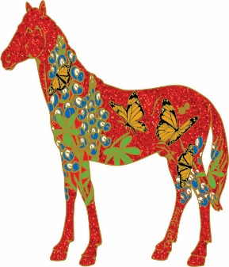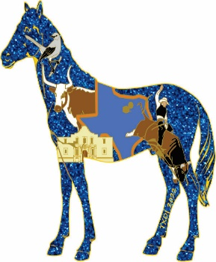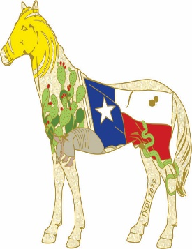
Spirit Horse-Red State Pin Spirit Horse-Blue State Pin Spirit Horse- White State Pin

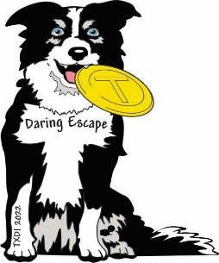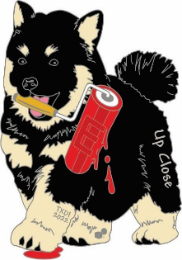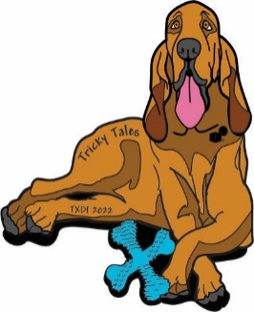
Tech Pin- Daring Escape (T pin) Scientific- Up Close (E pin) Fine Arts- Tricky Tales (X pin)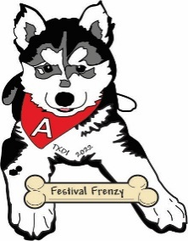 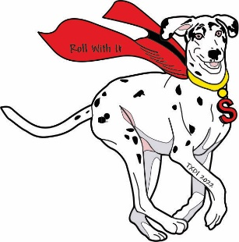 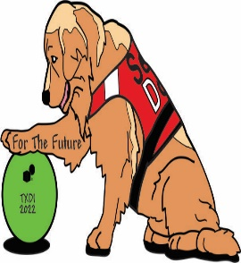 Improv- Festival Frenzy (A pin) Engineering- Roll with It (S pin) Service Learning- For the Future(D)

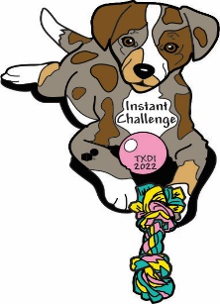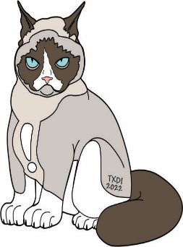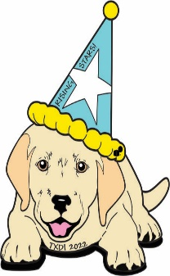
Instant Challenge- (I pin) TX Extreme (! Pin) Early Learning- Monsters Manner

