Texas Destination Imagination 2022 State Tournament Team Order Worksheet
$3.00 per pin sold before March 8, 2022. Prices will increase for on-site sales. The challenge pins as a group, spell our TEXAS DI! Please make your selections and return to your team manager by ______.
Student’s Name________ Team Name______ Number of Pins___@$3 each T-shirt size___@$16.00 (youth small through Adult XLarge) Total Amount Due:
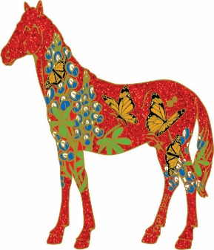 ___@ $3 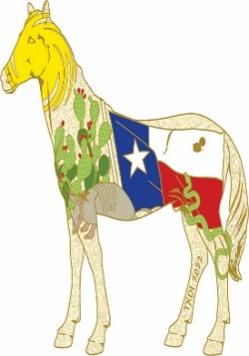 ___@$3 __@$3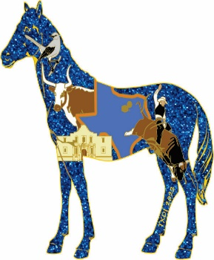
Spirit Horse-Red State Pin Spirit Horse-White State Pin Spirit Horse- Blue State Pin

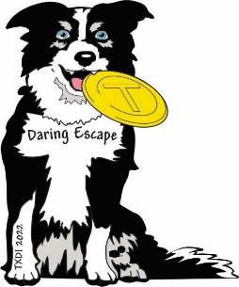 __@$3 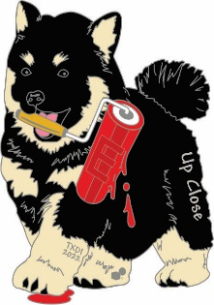 _@$3 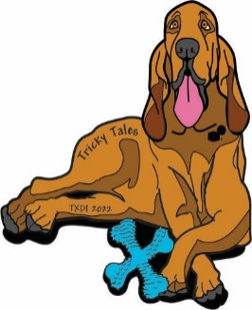__@$3
Tech Pin- Daring Escape (T pin) Scientific- Up Close (E pin) Fine Arts- Tricky Tales (X pin)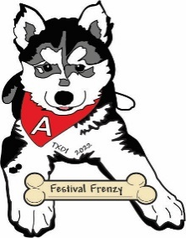 __@$3 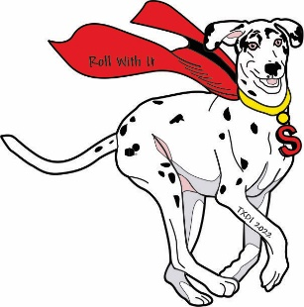 __@$3 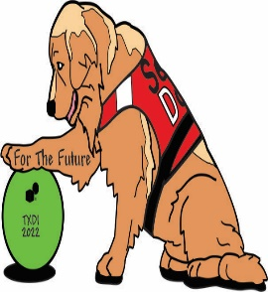 __@$3 Improv- Festival Frenzy (A pin) Engineering- Roll with It (S pin) Service Learning- For the Future(D)

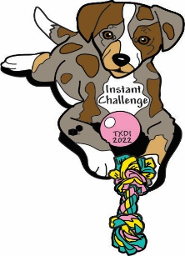 _@$3 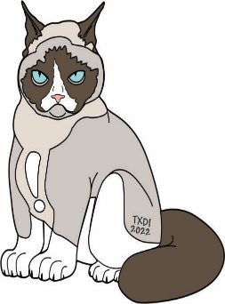 _@$3 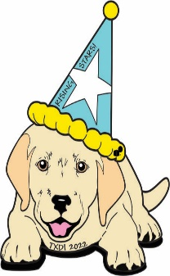__@$3
Instant Challenge- (I pin) TX Extreme (! Pin) Early Learning- Monsters Manner
T-shirt Image coming soon

