Register Your Team - Register Your Team

DESTINATION
IMAGINATIONS
•••
••
•
REGISTER YOUR TEAM

Tournament Registration Invoice

School District:

Invoice/Team #750- Challenge: Level,
Tournament: Texas Destination Imagination- State Tournament Registration
Paid to
Texas Destination Imagination
Statement date January 27, 2023

Tournament Fees

Tournament Fee

Total Tournament Fees Transactions
Total Transactions Balance
350.00

350.00

0.00

350.00

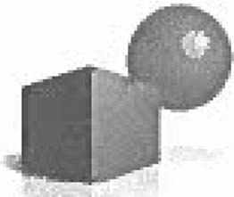
Paying by check: Texas Destination does not accept personal checks. However, school checks are accepted. Schools may make checks payable to Texas Destination Imagination, P.O. Box 8634, Greenville, TX 75404. Personal checks will be returned. We do not accept personal checks. Please allow 2-3 business days for processing. Teams will not be allowed to compete without meeting the payment deadline. Please plan accordingly. Teams will not be scheduled without a P.O. or payment on file by March 3, 2023.
Paying by PO: Texas Destination Imagination accepts school district purchase orders. Please scan the official purchase order to jarvisj@greenvilleisd.com by noon on March 3, 2023 (by noon). Purchase orders should be payable to Texas Destination Imagination or TXCPSO, P.O. Box 8634, Greenville, TX 75404. Please allow 2-3 business days for processing. Teams will not be scheduled if the deadline is not met.

