**Texas Destination Imagination Lone Star Finals Pins and T-shirt Worksheet**

**Name:**

**Pins $3 each**

# Ship(s)_____

# Truck (s)_____

# Airplane(s)_____

# T:_____

#E_______

#X_______

#A_______

#S_______

#D_______

#I________

#!________

#RS_______

**Total Pins____**

**T-shirts $17.00 each**

#YM______

#YL_______

#AS_______

#AM______

#AL_______

#AXL______

#2XL______

#3XL______

#4XL______

Total ____

**Pin and T-shirt Total**

$______________

**All orders must be placed with the team. The team manager will place one team order at registeryourteam.org before March 3, 2023.**

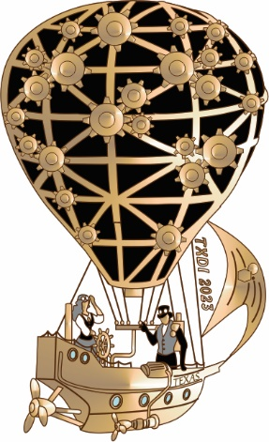  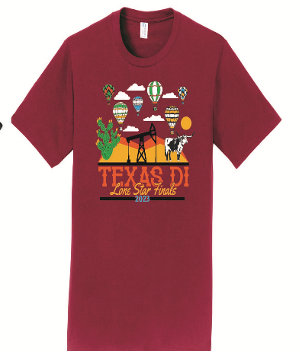

Ship Truck Airplane State T-shirt

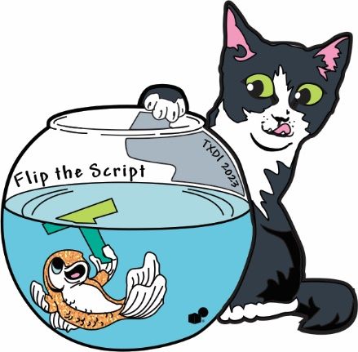 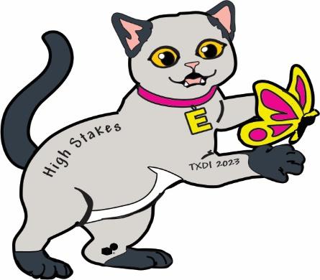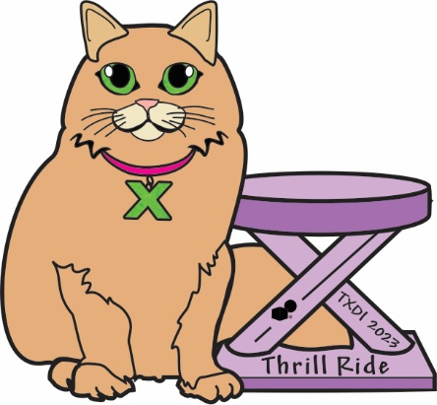

T: Fine Arts E: Service Learning X: Engineering

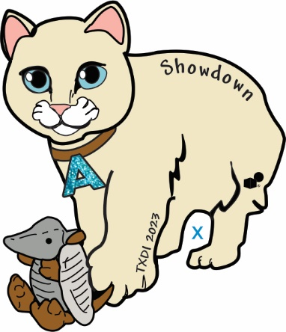 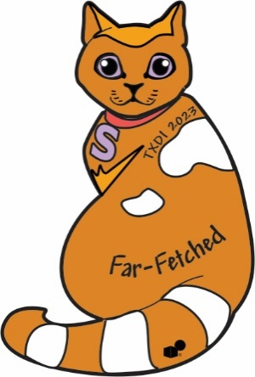 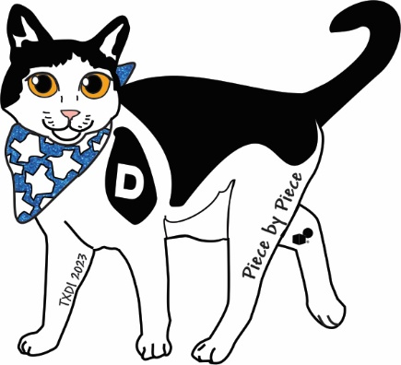

A: Improv S: Scientific D: Tech

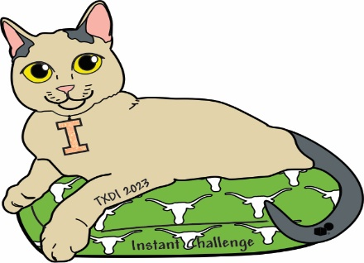  

I: Instant Challenge !:TX Extreme RS:Rising Star